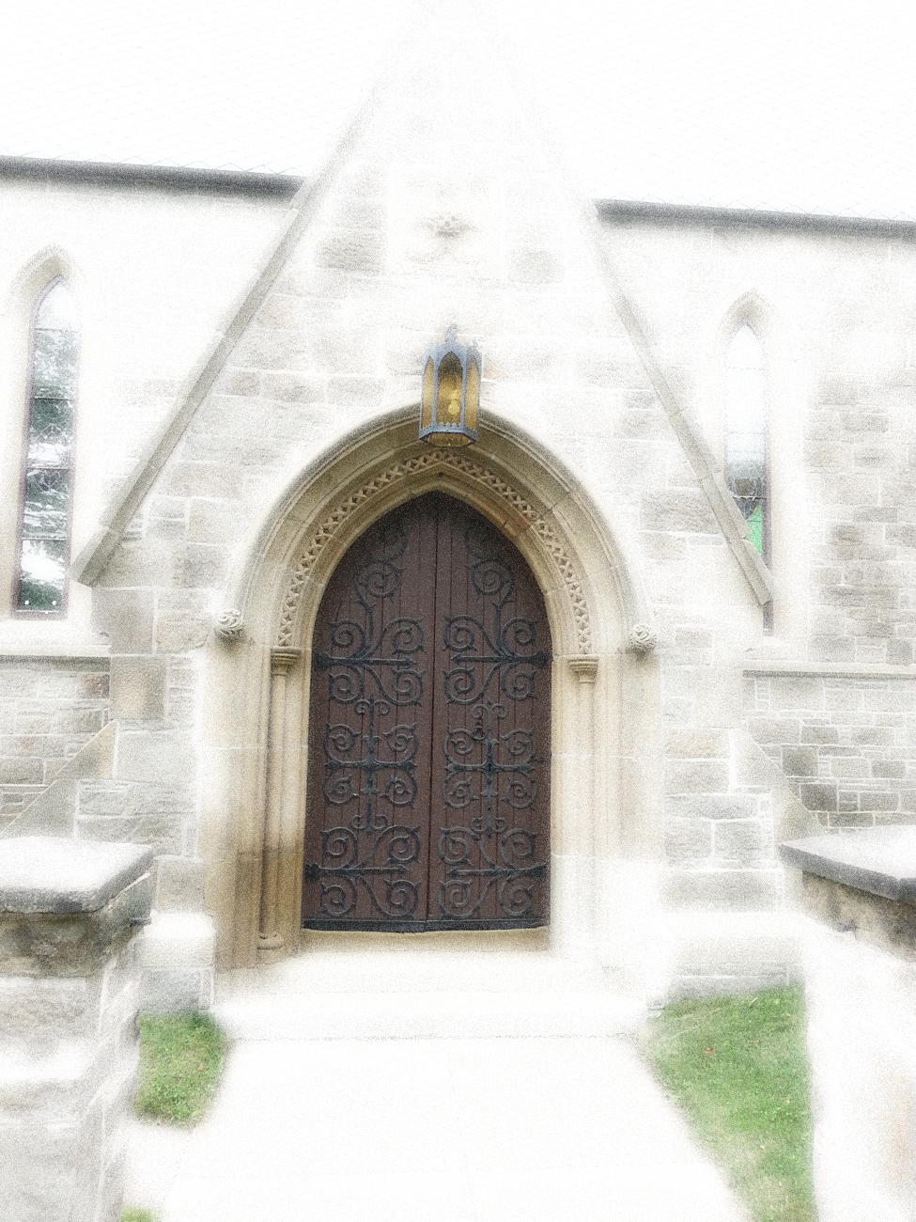
SUMMER EMPLOYMENT OPPORTUNITY
St. Anne’s Chapel of Ease - 245 Westmorland St. Fredericton
Period of Employment: 27 June 2022 to 26 August 2022.
Salary: $420.00 weekly. Hours: 30 per week - Monday to Friday.
Open to: Youth Ages 15+ who are legally eligible to work in Canada.
Duties: Give guided tours of our historic chapel - 15 Hours
AND a variety of Clerical and Custodial duties - 15 Hours.
Successful candidate must possess
excellent oral English communication.
Be reliable and dependable.
Training will be provided. Onsite supervision.
Send your resume to Christ Church Parish Church
AT ccpc@nb.aibn.com
Application deadline: April 23, 2022.
Fun Fact: St Anne’s Chapel is the oldest in Fredericton. Built in 1847, it resembles 13th century Gothic architecture. It was the home Church of Bliss Carman and Sir Charles G.D. Roberts. Bliss and Charles were cousins. Charles’s father was the Rector from 1874 to 1905.
If you enjoy talking to people, love history and would like to learn more about Fredericton’s past this opportunity is for you. This position is subject to funding by Canada Summer Jobs 2022. All candidates will be contacted by 13 May 2022. For more details please call 506 - 451 - 0630.

